Time
# Source: AI Source: Provided by: [Data Path: Persons Table -> ID Column: 1, Name_En Column: Motasem Essam] -> From: [ChatGPT] on [7/17/2026]
Time is the measurement of the duration of events and the interval between two occurrences. It is one of the seven base quantities in the International System of Units (SI) and is fundamental to physics, astronomy, engineering, navigation, communication, computing, and everyday life.
Time allows us to describe when events occur, how long they last, and the sequence in which they happen.

Definition
# Source: AI Source: Provided by: [Data Path: Persons Table -> ID Column: 1, Name_En Column: Motasem Essam] -> From: [ChatGPT] on [7/17/2026]
Time is the physical quantity that measures the duration between events or the progression of events from the past through the present into the future.
The SI base unit of time is the second (s).

Purpose
# Source: AI Source: Provided by: [Data Path: Persons Table -> ID Column: 1, Name_En Column: Motasem Essam] -> From: [ChatGPT] on [7/17/2026]
Time measurement is used to:
- Measure the duration of events.
- Schedule activities.
- Synchronize systems.
- Record scientific observations.
- Control industrial processes.
- Support navigation and communication.
- Perform calculations involving motion and change.

SI Unit
# Source: AI Source: Provided by: [Data Path: Persons Table -> ID Column: 1, Name_En Column: Motasem Essam] -> From: [ChatGPT] on [7/17/2026]
The SI base unit of time is:
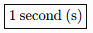
1 second (s)
The second is defined using the frequency of the radiation corresponding to the transition between two hyperfine energy levels of the ground state of the cesium-133 atom.

Common Units of Time
# Source: AI Source: Provided by: [Data Path: Persons Table -> ID Column: 1, Name_En Column: Motasem Essam] -> From: [ChatGPT] on [7/17/2026]
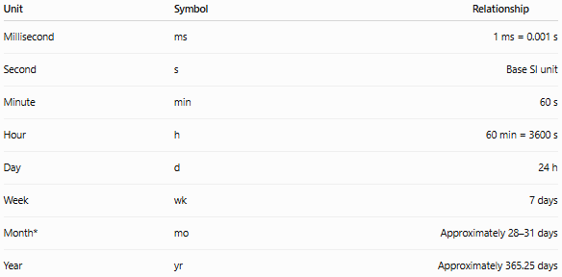
Unit | Symbol | Relationship
Millisecond | ms | 1 ms = 0.001 s
Second | s | Base SI unit
Minute | min | 60 s
Hour | h | 60 min = 3600 s
Day | d | 24 h
Week | wk | 7 days
Month* | mo | Approximately 28–31 days
Year | yr | Approximately 365.25 days
*The length of a month varies depending on the calendar.

Measuring Instruments
# Source: AI Source: Provided by: [Data Path: Persons Table -> ID Column: 1, Name_En Column: Motasem Essam] -> From: [ChatGPT] on [7/17/2026]
Time can be measured using:
- Clock
- Wristwatch
- Stopwatch
- Timer
- Atomic clock
- Chronometer
- Digital clock

Measurement Process
# Source: AI Source: Provided by: [Data Path: Persons Table -> ID Column: 1, Name_En Column: Motasem Essam] -> From: [ChatGPT] on [7/17/2026]
To measure time:
- Select an appropriate time-measuring device.
- Start the measurement at the beginning of the event.
- Stop the measurement when the event ends.
- Read and record the elapsed time with the correct unit.

Examples
# Source: AI Source: Provided by: [Data Path: Persons Table -> ID Column: 1, Name_En Column: Motasem Essam] -> From: [ChatGPT] on [7/17/2026]
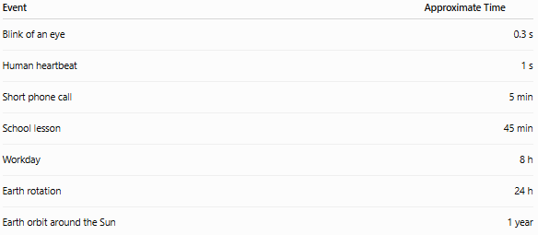
Event | Approximate Time
Blink of an eye | 0.3 s
Human heartbeat | 1 s
Short phone call | 5 min
School lesson | 45 min
Workday | 8 h
Earth rotation | 24 h
Earth orbit around the Sun | 1 year

Unit Conversions
# Source: AI Source: Provided by: [Data Path: Persons Table -> ID Column: 1, Name_En Column: Motasem Essam] -> From: [ChatGPT] on [7/17/2026]
Common conversions:
- 1 minute = 60 seconds
- 1 hour = 60 minutes
- 1 day = 24 hours
- 1 hour = 3600 seconds
- 1 week = 7 days
Examples:
- 5 min = 300 s
- 2 h = 120 min
- 3 days = 72 h

Accuracy
# Source: AI Source: Provided by: [Data Path: Persons Table -> ID Column: 1, Name_En Column: Motasem Essam] -> From: [ChatGPT] on [7/17/2026]
Accurate time measurement depends on:
- High-quality timing devices.
- Proper synchronization.
- Stable oscillation or frequency source.
- Regular calibration.
Atomic clocks provide the highest level of time accuracy.

Precision
# Source: AI Source: Provided by: [Data Path: Persons Table -> ID Column: 1, Name_En Column: Motasem Essam] -> From: [ChatGPT] on [7/17/2026]
Precision refers to the consistency of repeated time measurements.
Example:
Repeated measurements:
- 10.001 s
- 10.002 s
- 10.001 s
These measurements are highly precise.

Applications
# Source: AI Source: Provided by: [Data Path: Persons Table -> ID Column: 1, Name_En Column: Motasem Essam] -> From: [ChatGPT] on [7/17/2026]
Time measurement is essential in:
- Physics
- Astronomy
- Engineering
- Computing
- Telecommunications
- Navigation
- Transportation
- Manufacturing
- Sports
- Scientific research

Everyday Importance
# Source: AI Source: Provided by: [Data Path: Persons Table -> ID Column: 1, Name_En Column: Motasem Essam] -> From: [ChatGPT] on [7/17/2026]
Time measurement is used daily for:
- Scheduling appointments.
- School and work timetables.
- Cooking.
- Sporting events.
- Public transportation.
- Communication networks.
- Navigation systems.
- Computer operations.

Common Mistakes
# Source: AI Source: Provided by: [Data Path: Persons Table -> ID Column: 1, Name_En Column: Motasem Essam] -> From: [ChatGPT] on [7/17/2026]
- Confusing elapsed time with the time of day.
- Using the wrong unit (seconds instead of minutes, for example).
- Starting or stopping a timer at the wrong moment.
- Using an unsynchronized clock.
- Ignoring calibration in precision applications.

Key Points
# Source: AI Source: Provided by: [Data Path: Persons Table -> ID Column: 1, Name_En Column: Motasem Essam] -> From: [ChatGPT] on [7/17/2026]
- Time measures the duration between events.
- The SI base unit is the second (s).
- Time is measured using clocks, watches, timers, stopwatches, and atomic clocks.
- Accurate time measurement is essential for science, engineering, navigation, communication, and everyday activities.
- Atomic clocks provide the international reference for precise time measurement.

Time vs. Duration
# Source: AI Source: Provided by: [Data Path: Persons Table -> ID Column: 1, Name_En Column: Motasem Essam] -> From: [ChatGPT] on [7/17/2026]
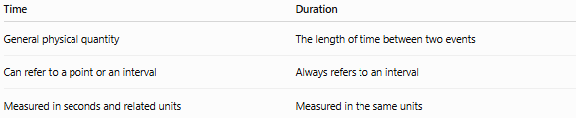
Time | Duration
General physical quantity | The length of time between two events
Can refer to a point or an interval | Always refers to an interval
Measured in seconds and related units | Measured in the same units

Time vs. Date
# Source: AI Source: Provided by: [Data Path: Persons Table -> ID Column: 1, Name_En Column: Motasem Essam] -> From: [ChatGPT] on [7/17/2026]
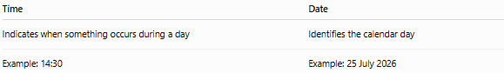
Time | Date
Indicates when something occurs during a day | Identifies the calendar day
Example: 14:30 | Example: 25 July 2026

Time vs. Frequency
# Source: AI Source: Provided by: [Data Path: Persons Table -> ID Column: 1, Name_En Column: Motasem Essam] -> From: [ChatGPT] on [7/17/2026]
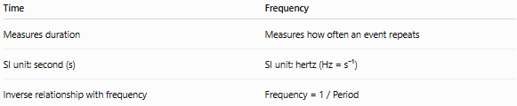
Time | Frequency
Measures duration | Measures how often an event repeats
SI unit: second (s) | SI unit: hertz (Hz = s⁻¹)
Inverse relationship with frequency | Frequency = 1 / Period

Date
# Source: AI Source: Provided by: [Data Path: Persons Table -> ID Column: 1, Name_En Column: Motasem Essam] -> From: [ChatGPT] on [7/17/2026]
A Date is a measurement of time that identifies a specific day within a calendar system. It enables people to organize events, record history, schedule activities, and calculate time intervals.
Dates are used worldwide in education, science, business, government, medicine, transportation, computing, and everyday life.

Definition
# Source: AI Source: Provided by: [Data Path: Persons Table -> ID Column: 1, Name_En Column: Motasem Essam] -> From: [ChatGPT] on [7/17/2026]
A Date is a standardized representation of a specific day within a calendar system, typically expressed using the day, month, and year.

Purpose
# Source: AI Source: Provided by: [Data Path: Persons Table -> ID Column: 1, Name_En Column: Motasem Essam] -> From: [ChatGPT] on [7/17/2026]
Dates are used to:
- Identify a specific day.
- Record historical events.
- Schedule appointments.
- Plan future activities.
- Calculate age and duration.
- Track deadlines.
- Organize records and databases.

Basic Components of a Date
# Source: AI Source: Provided by: [Data Path: Persons Table -> ID Column: 1, Name_En Column: Motasem Essam] -> From: [ChatGPT] on [7/17/2026]
A complete date usually consists of:
- Day
- Month
- Year
Example:
25 April 2026
Where:
- Day = 25
- Month = April
- Year = 2026

Common Date Formats
# Source: AI Source: Provided by: [Data Path: Persons Table -> ID Column: 1, Name_En Column: Motasem Essam] -> From: [ChatGPT] on [7/17/2026]
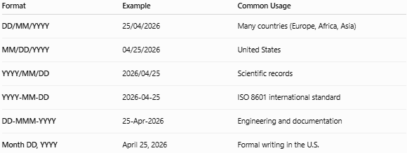
Format | Example | Common Usage
DD/MM/YYYY | 25/04/2026 | Many countries (Europe, Africa, Asia)
MM/DD/YYYY | 04/25/2026 | United States
YYYY/MM/DD | 2026/04/25 | Scientific records
YYYY-MM-DD | 2026-04-25 | ISO 8601 international standard
DD-MMM-YYYY | 25-Apr-2026 | Engineering and documentation
Month DD, YYYY | April 25, 2026 | Formal writing in the U.S.

Types of Dates

1. Calendar Date
# Source: AI Source: Provided by: [Data Path: Persons Table -> ID Column: 1, Name_En Column: Motasem Essam] -> From: [ChatGPT] on [7/17/2026]
The standard civil date used in everyday life.
Example:
- 25 April 2026
Applications:
- Birthdays
- Meetings
- School schedules

2. Historical Date
# Source: AI Source: Provided by: [Data Path: Persons Table -> ID Column: 1, Name_En Column: Motasem Essam] -> From: [ChatGPT] on [7/17/2026]
Used to record important historical events.
Examples:
- 20 July 1969 (Apollo 11 Moon landing)
- 4 July 1776 (U.S. Declaration of Independence)
Applications:
- History
- Museums
- Archives

3. Fiscal Date
# Source: AI Source: Provided by: [Data Path: Persons Table -> ID Column: 1, Name_En Column: Motasem Essam] -> From: [ChatGPT] on [7/17/2026]
Used in accounting and finance according to a fiscal year rather than a calendar year.
Example:
- Fiscal Year 2026
Applications:
- Accounting
- Government
- Business

4. Manufacturing Date (MFG)
# Source: AI Source: Provided by: [Data Path: Persons Table -> ID Column: 1, Name_En Column: Motasem Essam] -> From: [ChatGPT] on [7/17/2026]
Indicates when a product was manufactured.
Example:
- MFG: 15/02/2026
Applications:
- Food
- Pharmaceuticals
- Manufacturing

5. Expiration Date (EXP)
# Source: AI Source: Provided by: [Data Path: Persons Table -> ID Column: 1, Name_En Column: Motasem Essam] -> From: [ChatGPT] on [7/17/2026]
Indicates the last recommended date for safe or effective use.
Example:
- EXP: 15/02/2028
Applications:
- Food products
- Medicines
- Cosmetics

6. Due Date
# Source: AI Source: Provided by: [Data Path: Persons Table -> ID Column: 1, Name_En Column: Motasem Essam] -> From: [ChatGPT] on [7/17/2026]
The date by which a task or payment should be completed.
Examples:
- Assignment due date
- Loan payment due date
Applications:
- Education
- Finance
- Business

7. Issue Date
# Source: AI Source: Provided by: [Data Path: Persons Table -> ID Column: 1, Name_En Column: Motasem Essam] -> From: [ChatGPT] on [7/17/2026]
The date on which a document was officially created or released.
Examples:
- Passport issue date
- Invoice issue date
- Certificate issue date

8. Effective Date
# Source: AI Source: Provided by: [Data Path: Persons Table -> ID Column: 1, Name_En Column: Motasem Essam] -> From: [ChatGPT] on [7/17/2026]
The date on which a contract, law, or policy becomes active.
Applications:
- Legal documents
- Employment contracts
- Insurance policies

9. Revision Date
# Source: AI Source: Provided by: [Data Path: Persons Table -> ID Column: 1, Name_En Column: Motasem Essam] -> From: [ChatGPT] on [7/17/2026]
The date a document or drawing was updated.
Applications:
- Engineering drawings
- Technical manuals
- Standards documentation

10. Timestamp
# Source: AI Source: Provided by: [Data Path: Persons Table -> ID Column: 1, Name_En Column: Motasem Essam] -> From: [ChatGPT] on [7/17/2026]
A date combined with the exact time.
Example:
- 2026-04-25 14:30:45
Applications:
- Databases
- Computer systems
- Security logs
- Programming

Date Representation Standards
# Source: AI Source: Provided by: [Data Path: Persons Table -> ID Column: 1, Name_En Column: Motasem Essam] -> From: [ChatGPT] on [7/17/2026]
ISO 8601
International standard:
YYYY-MM-DD
Example:
- 2026-04-25
Advantages:
- Eliminates ambiguity.
- Sorts chronologically.
- Widely used in computing.

Months of the Year
# Source: AI Source: Provided by: [Data Path: Persons Table -> ID Column: 1, Name_En Column: Motasem Essam] -> From: [ChatGPT] on [7/17/2026]
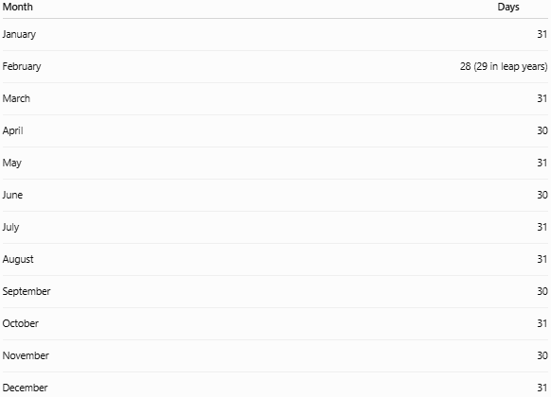
Month | Days
January | 31
February | 28 (29 in leap years)
March | 31
April | 30
May | 31
June | 30
July | 31
August | 31
September | 30
October | 31
November | 30
December | 31

Leap Year
# Source: AI Source: Provided by: [Data Path: Persons Table -> ID Column: 1, Name_En Column: Motasem Essam] -> From: [ChatGPT] on [7/17/2026]
A Leap Year contains 366 days instead of 365.
February has:
- 28 days (normal year)
- 29 days (leap year)
A year is generally a leap year if:
- It is divisible by 4,
- Except years divisible by 100, unless they are also divisible by 400.
Examples:
- 2024 ✔
- 2028 ✔
- 2100 ✘
- 2000 ✔

Date Calculations
# Source: AI Source: Provided by: [Data Path: Persons Table -> ID Column: 1, Name_En Column: Motasem Essam] -> From: [ChatGPT] on [7/17/2026]
Common operations include:
- Finding age
- Calculating duration
- Counting days between dates
- Determining weekdays
- Scheduling future dates
Example:
25 April 2026 → 5 days later = 30 April 2026

Applications
# Source: AI Source: Provided by: [Data Path: Persons Table -> ID Column: 1, Name_En Column: Motasem Essam] -> From: [ChatGPT] on [7/17/2026]
Dates are used in:
- Education
- Banking
- Healthcare
- Manufacturing
- Government
- Transportation
- Computer systems
- Scientific research
- Legal documentation

Advantages of Standardized Dates
# Source: AI Source: Provided by: [Data Path: Persons Table -> ID Column: 1, Name_En Column: Motasem Essam] -> From: [ChatGPT] on [7/17/2026]
Standardized date formats:
- Improve communication.
- Reduce ambiguity.
- Simplify international data exchange.
- Support accurate record keeping.
- Facilitate computer processing.

Common Mistakes
# Source: AI Source: Provided by: [Data Path: Persons Table -> ID Column: 1, Name_En Column: Motasem Essam] -> From: [ChatGPT] on [7/17/2026]
- Confusing DD/MM/YYYY with MM/DD/YYYY.
- Forgetting leap years.
- Using inconsistent formats in the same document.
- Omitting the year when long-term clarity is required.
- Misinterpreting ambiguous numeric dates (e.g., 04/05/2026).

Key Points
# Source: AI Source: Provided by: [Data Path: Persons Table -> ID Column: 1, Name_En Column: Motasem Essam] -> From: [ChatGPT] on [7/17/2026]
- A Date identifies a specific day within a calendar system.
- It is composed of day, month, and year.
- Common types include:
  - Calendar Date
  - Historical Date
  - Fiscal Date
  - Manufacturing Date
  - Expiration Date
  - Due Date
  - Issue Date
  - Effective Date
  - Revision Date
  - Timestamp
- ISO 8601 (YYYY-MM-DD) is the internationally recognized standard for unambiguous date representation.

Conclusion
# Source: AI Source: Provided by: [Data Path: Persons Table -> ID Column: 1, Name_En Column: Motasem Essam] -> From: [ChatGPT] on [7/17/2026]
A Date is a fundamental method of measuring time that identifies a specific day within a calendar system. Different types of dates serve specialized purposes in fields such as history, manufacturing, business, law, healthcare, and computing. Using standardized date formats—especially ISO 8601—helps ensure consistency, reduces ambiguity, and supports reliable communication and data management across different countries and industries.

Conclusion
# Source: AI Source: Provided by: [Data Path: Persons Table -> ID Column: 1, Name_En Column: Motasem Essam] -> From: [ChatGPT] on [7/17/2026]
Time is the measurement of the duration of events and the interval between them. It is one of the seven SI base quantities, with the second (s) as its standard unit. Defined using the cesium-133 atomic transition, the second provides an extremely stable and precise basis for modern measurement. Time measurement is fundamental to science, engineering, communication, navigation, computing, manufacturing, and everyday life, enabling accurate synchronization, scheduling, and analysis of events.

